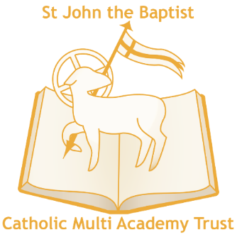

As God’s family we nurture and inspire our children by broadening their horizons as they learn. Through rich and varied experiences, we enable them to be a loving and caring influence on our world

St Mary's Roman Catholic Primary School, Kirkley Cliff, Lowestoft, Suffolk, NR33 0DG
Email: office@stmarysrcps.org
Tel: 01502 565 384

Year 3 Class Teacher
- Salary: MPS- Post suitable for an NQT
- Permanent
- Full time
- Required for September 2021

St Mary’s Roman Catholic Primary School is a welcoming and vibrant Primary School situated in Lowestoft. Staff, parents and Governors are very proud of the school and recognise it is a delightful place to grow and learn. We welcome applicants from all faiths and backgrounds.
The school is part of St John the Baptist Catholic Multi Academy Trust and the successful candidate will have the opportunity to share practice across the Trust and contribute to the future success of our school. The school shares an Executive Head with another local Catholic school and there is a tradition of long established joint support between the two schools and the aspiration to share more leadership, staffing, CPD and vision to be the best possible environments for learning, growth and spiritual development.
We are looking for an enthusiastic and tenacious Year 3 Class Teacher to join the school as part of our highly committed team. This post is suitable for a proactive and enthusiastic NQT, whom we can support well through our MATs Teaching School Hub and underpinned by the Early Career Framework. Staff wellbeing is at the centre of our practice and we are looking for a class teacher who is passionate about learning.
You will be
- An enthusiastic, well-motivated and forward thinking KS2 teacher
- A tenacious practitioner who has drive and passion to continue the journey towards excellence.
- An outstanding, fun and creative classroom practitioner with high expectations for pupils’ work and behaviour
- Good knowledge and understanding of the curriculum
We can offer you:
- Friendly and enthusiastic children
- Excellent support from our dedicated team of staff
- An enthusiastic and supportive Executive Head Teacher and Head of School who put the interests of the children first
- A commitment to on-going professional development
- Strong links with the Trust, community and church
- A school committed to staff well-being

Visits to the school are warmly welcomed following our schools risk assessment, to arrange an appointment please call: 01502 565384
For an application form and further details, please visit the school website https://www.stmarysrcps.com/.

Closing date for applications: Friday 25th June 2021 at midday.
Shortlisting date: Monday 28th June 2021
Interview date: Wednesday 30th June 2021

Application forms should be returned to office@stmarysrcps.org or by post to Mrs E Parker, Head of School, Kirkley Cliff, Lowestoft, NR33 0DG

Applicants should be supportive of our catholic ethos. St John the Baptist CMAT welcomes applications from members of minority ethnic communities and those with disabilities. The MAT is committed to safeguarding and promoting the welfare of children and young people and expects all staff and volunteers to share this commitment. You will be subject to DBS checks along with relevant employment checks.

