
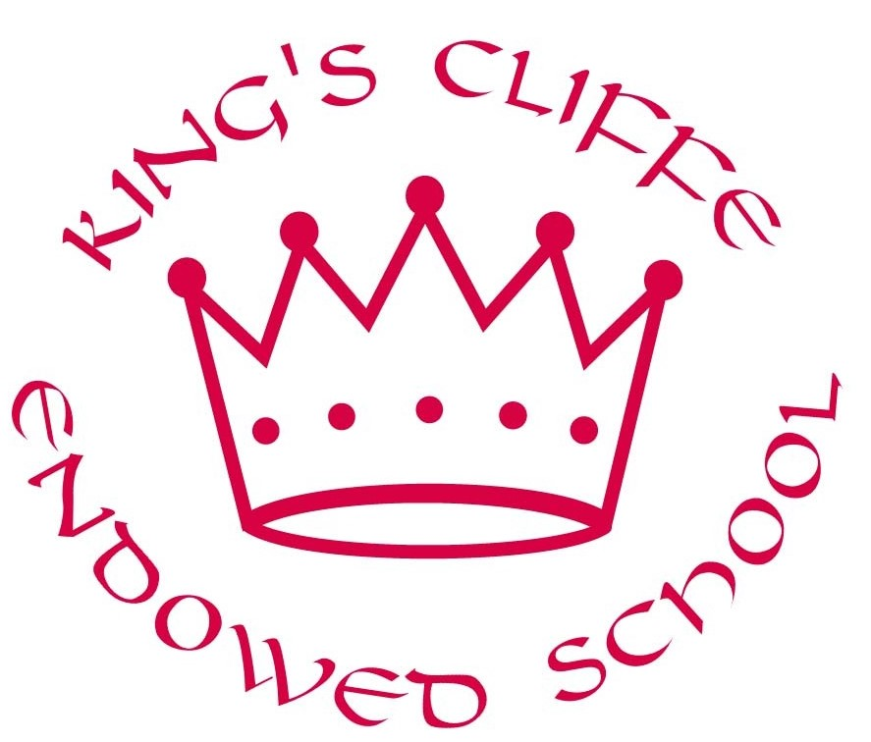

Job Description

Details of the job
Post title: | Teacher
Reporting to: | Deputy/Curriculum Lead
Salary grade: | Main scale
Hours: | Full-time or Part-time

Overall purpose of the post

To ensure high quality education for all pupils for which you are responsible and accountable and improve the quality of learning and standards of achievement.

Principal responsibilities

- To fulfil the duties of a teacher and the relevant professional standards as outlined in the School Teachers’ Pay and Conditions Document.
- To provide a secure, happy and caring environment for all children in the class.
- To plan, prepare and deliver appropriate educational experiences, which address individual needs through quality teaching and high expectations.
- To ensure that educational needs of all pupils in your class are fully met and liaise with the Inclusion Manager where necessary to support children with special needs.
- To ensure that all pupils make good progress within an academic year
- To implement interventions and support measures to support children who are not on track to meet their end of Key Stage targets.
- To inform the Inclusion Manager of any concerns relating to the development of a child.
- To assess, monitor, record and report, on the progress and attainment of pupils. To administer national and school assessments thoroughly and to use the information to improve standards.
- To follow the school’s marking policy ensuring that children are given comprehensive feedback about the learning and how they can improve in future pieces of work.
- To communicate and consult with parents/carers, through written and oral reports. To keep a record of discussions held.
- To liaise effectively with professional agencies, e.g., Health visitor, speech therapist, educational psychologists.
- To participate fully in all staff meetings, and to be involved in appropriate staff development.
- To take an active role in the development of all School Policies and Schemes of Work.
- To maintain high standards of discipline and to ensure that all children are safe by following the Health and Safety Policy.
- To assist with the training of students and contribute towards their assessments (not applicable to ECTs)
- To work closely with teaching assistants offering support and guidance in the lesson objectives to ensure quality provision is given through understood goals.
- To maintain an attractive, stimulating and well organised learning environment including displaying children’s work effectively and directing support staff to assist with this.
- To contribute to the design and provision of an engaging curriculum as and when requested by subject leaders/senior managers.
- To reflect systematically on the effectiveness of lessons and approaches to teaching.
- To keep informed of changes in education nationally, as they impact upon the phase of education in which the teacher works, including changes to assessment and curriculum arrangements.
- To attend staff meetings and Training Days in accordance with directed time allocations and to take responsibility for improving your own teaching practice.
- To be responsible for the safeguarding and wellbeing of children by following school policy relating to safeguarding, health and safety and behaviour management.
- To make a positive contribution to the wider school life and ethos of the school.
- To develop effective, professional relationships with colleagues, knowing how and when to draw on advice and professional support.
- To have proper and professional regard for the ethos, policies and practices of the school and maintain high standards in your own attendance and punctuality.
- To act within the statutory frameworks which set out your professional duties and responsibilities.

