Class Teacher – Temporary (2 terms) – 2.5 days per week - (MPS 1 – 6)

Sandbach Primary Academy are looking to appoint a Class Teacher to work in a mixed Year 5/6 class for 2.5 days per week. The successful candidate will be a high-quality classroom teacher who enjoys working as part of a team and is willing to adapt to the varying needs of the school at any given time.

We are looking for a teacher who has the desire and the drive to not only be an outstanding classroom practitioner but also contribute to the wider life of the school to improve opportunities for our pupils. To be successful, you will be well organised, motivated, resilient and flexible with high expectations of attainment, achievement and behaviour and have the drive to make a difference to the education of all our pupils. You will have excellent communication and organisation skills.

We are a friendly, inclusive school and were recently judged to be a good school by Ofsted (October 2024). We are looking for someone who is passionate about children and learning to join our nurturing team.

We are a member of The Aspire Multi Academy Trust and offer a mutually supportive ethos with excellent opportunities for professional development. We are proud to be a Disability Confident Committed Employer, we strongly encourage applications from all persons with a known disability. We aim to ensure a fully inclusive and accessible recruitment process.

To apply, please submit a letter of application and complete the Aspire Educational Trust application form.

If you request any support or have any questions, please contact:
Name: Lesley Greenwood
Phone: 01270 918922
Email: admin@sandbach-pri.cheshire.sch.uk

As a Trust we are committed to safeguarding and promoting the welfare of our children. For all shortlisted candidates reference checks and online searches will be completed prior to interview. All successful candidates are subject to satisfactory references, medical checks, right to work in UK and safeguarding checks (including enhanced DBS and a declaration of disqualification (Childcare Disqualification regulations 2009).

If you are committed to helping children thrive and getting the best start in life, then we look forward to hearing from you.

Opportunity to visit the school for a tour: 01270 918922 (please call or email to arrange)
Closing Date: Monday 13th October 2025 at 9am
Start Date: January 2026
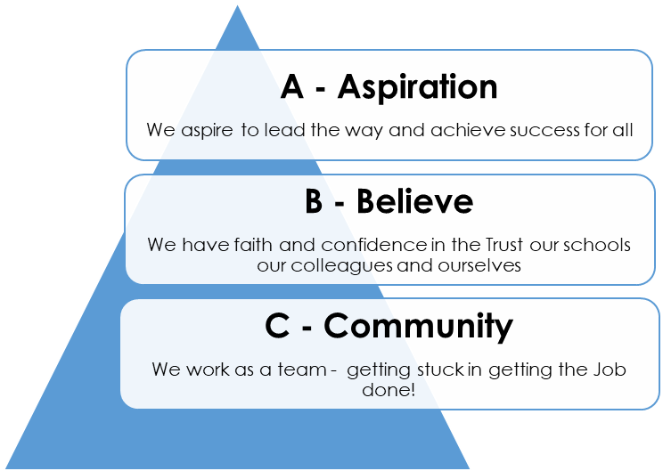
Please return email to: admin@sandbach-pri.cheshire.sch.uk

