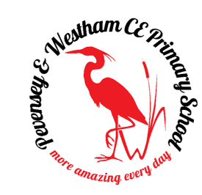
Pevensey & Westham CE Primary School

Requires a Year 6 Class Teacher

We have a rare opportunity to join the team at Pevensey & Westham
CE Primary School initially for a year to work with our Year 6 Team to enable smaller classes.

We have a committed, enthusiastic and caring staff team. We are a church school, set in a beautiful, historic environment, that provides a “rich and inspiring curriculum”; this helps to provide our pupils with the tools to achieve ‘fullness of life’.

We are looking for someone to join our teaching team. You will help us to ensure high outcomes for our Year 6 pupils. You will have high expectations of children’s learning and behaviour and will also be able to support the Christian ethos of the School.

We have a strong focus on staff wellbeing. You will be supported by specialist teaching in several areas. We also offer high quality, bespoke CPD to aid professional development and provide opportunities for further progression.

The post is full time.
Salary: TMS1 £25,714 and TMS 6 £36,961

For more information about the School please visit our website or contact the school office on 01323 762269 or by email at admin@pevenseyschool.org.uk.

To apply for this position please visit the vacancies section of our website https://pevenseyschool.org.uk , please complete and return the teaching staff application form making sure you clearly outline why we should hire you.

Closing date: 20 May 2021 Noon
Interview date: tbc

Pevensey & Westham CEP School is committed to safeguarding and promoting the welfare of children and young people and expects all staff and volunteers to share this commitment. All staff will be expected to obtain an enhanced DBS Certificate with the Local Authority.

More amazing every day

