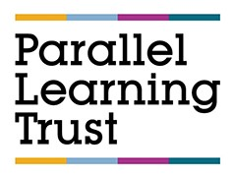
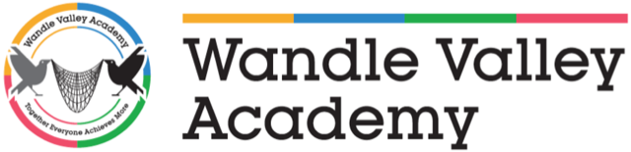

Position: Yr7 Transition Teacher, SEMH
Salary: Main Pay Scale/Upper Scale (depending on experience) + SEN1
School: Wandle Valley Academy, Carshalton
Required: As soon as possible

We reserve the right to close this vacancy early if we receive sufficient applications for the role.

Wandle Valley Academy is an SEMH school in Carshalton dedicated to pupils across all Key Stages with Social Emotional and Mental Health needs (SEMH). Some pupils have associated difficulties and can express severe and complex social and behavioural needs. A background and interest in working with SEMH children and young people is essential.

We have built an education community that we are incredibly proud of and are looking to find high quality teachers to join our team.

The Role: SEMH Transition Teacher

You will be a qualified teacher or have experience of teaching in secondary and or primary education. There will be significant gaps in the pupils’ knowledge and understanding which will need to be addressed and planned for. There is a real onus on teaching life skills which help to enhance their values, learning and interests as well as specialist 1:1 support. As a Class Teacher, you will be working closely with a range of support staff both inside and outside of the classroom. Class sizes are generally a maximum of 8 pupils.

Ideal Candidate

The ideal candidate will have experience of working with children and young people with severe social, emotional and behavioural difficulties. Due to the nature of the pupils, a fair, honest and assertive approach is needed. You must have strong classroom management skills and the ability to deal with complex and challenging behaviour.

Requirements

The role is open to more experienced teachers and NQT's or have experience of teaching in secondary and or primary education. Recent experience and a genuine passion for working in an SEMH environment is desirable. CPI training or any other form of positive handling will be advantageous but not essential as appropriate training will be provided.

Salary and Benefits

Main Pay Scale or Upper Pay Scale (dependent on experience) + SEN Allowance.

Wandle Valley Academy is part of the Parallel Learning Trust (PLT) which is a Multi Academy Trust committed to safeguarding and promoting the welfare of all pupils attending the Academy. As the duties of this post involves regular contact with children, any offer to the successful candidate will be conditional upon an Enhanced Disclosure being obtained via the Disclosure and Barring Service, medical clearance and satisfactory references. We will also carry out online searches on shortlisted candidates to help identify any incidents or issues that are publicly available online.

Applications submitted on the application form will only be considered. Please take care to complete the application form in full as incomplete applications will not be considered. Application forms can be found on the academy website – https://www.wandlevalleyacademy.org.uk/vacancies or alternatively please contact Toni Ahmet, on telephone: 020 8648 1365 or email: tahmet@wandlevalleyacademy.org.uk. Completed applications should be sent to Toni Ahmet.

CLOSING DATE: Friday 15th May 2026 at 12 NOON

