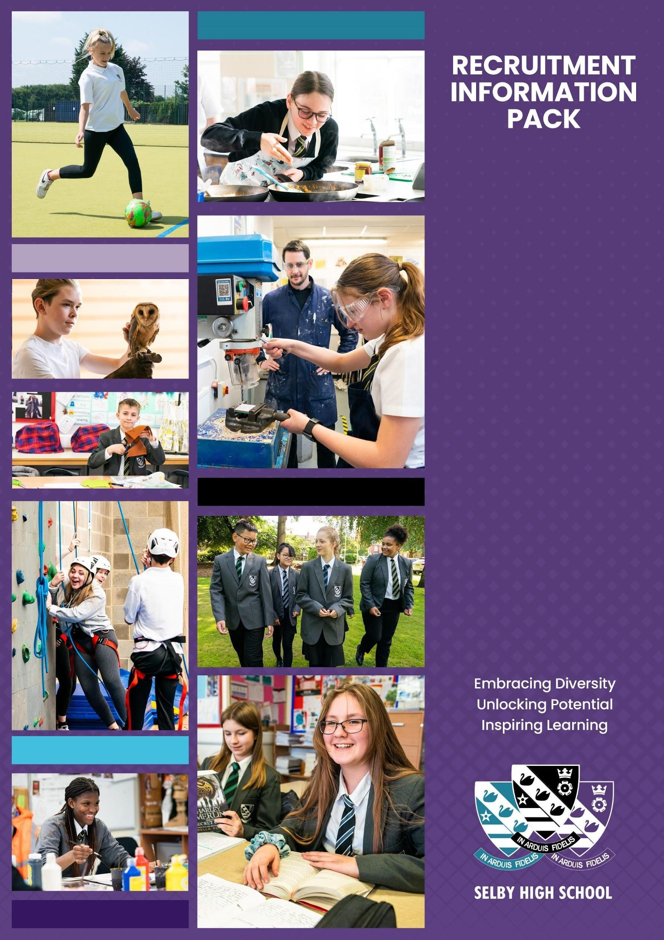

**Year Manager**

**January 2025**

**WELCOME**

Dear Candidate,

Thank you for your interest in the post of non-teaching Year Manager at Selby High School.  This is a fantastic opportunity for somebody looking to develop their career in pastoral work, and wanting to make a significant contribution to the success of the young people in our community.

We are looking for a determined, enthusiastic person who wants to support our young people, to ensure that, regardless of starting points or barriers to learning, they develop and grow both as learners and as young citizens of the world.  The successful candidate will have significant experience of working with young people, and a good knowledge of safeguarding and child protection issues. We are looking for candidates with the confidence and ability to take responsibility for the pastoral care of a year group; you will take a lead role in securing excellent behaviour and attendance, and in overseeing the wellbeing of the students in your group. You will be a creative thinker and a problem solver, able to take responsibility for your decisions.

At Selby High School, we believe that the pastoral team makes an essential contribution to the school. Year Managers are part of an extensive support team, and are line managed by a Key Stage Director.

Selby High School is an ambitious, forward looking, and successful 11-16 secondary school located in North Yorkshire and rated ‘good’ in our last inspection.  We are proud of our school and the opportunities it provides for both students and staff.  Our ambition is success for everyone through encouragement, teamwork, mutual respect and an enjoyment of learning.  We aim to create an environment where we all understand, that by supporting each other and working together, we achieve more.

We offer a comprehensive induction programme and continual professional development for our staff.  We will provide you with excellent training opportunities, and encourage you to have high aspirations for your future career.

Selby High School is a great place to work. Please, just take a little time to look at the whole school twitter feed [https://twitter.com/SelbyHigh](https://twitter.com/SelbyHigh%20) to see some of the opportunities of the school.  If you have a little longer to spend, our school website at <http://www.selbyhigh.n-yorks.sch.uk/> gives a real insight into the character of our school.

This information pack contains the Job Description and Person Specification, together with some background information about the school.  We hope this gives you a feel for Selby High School. If you wish to visit prior to putting in your application, then you would be most welcome. I look forward to receiving your application.

With all best wishes.

Yours faithfully



Nick Hinchliffe

Principal

**ABOUT SELBY**

Selby is a small market town situated 14 miles (22.5 km) south of the city of York, along the course of the River Ouse. It is dominated by the superb Abbey, founded in AD1069 by Benedict when he saw three swans on a lake in Selby which he interpreted as a sign of the Father, Son and Holy Ghost, resulting in the official crest of Selby Abbey, and subsequently, Selby High School.

Selby local government district has a population of 82,900. It is a fairly rural district with a population density well below the national average. Selby town, with a population of 24,680 is its only major settlement, with a population of more than 15,000.

Selby has a growing local economy with new housing and shops being built on the town's outskirts. The riverfront area is also being revamped with modern housing and flats. This is anticipated to bring population growth and enhanced demand for high quality educational places into the future. Selby is ideally located to a whole variety of places, facilities and activities for culture, leisure, commerce and learning. There is a wide range and variety of housing and prices are below the national average.

|  |  |
| --- | --- |
| The district of Selby is contained within both the Leeds City Region and the York, North Yorkshire and East Riding Enterprise Partnerships. The Leeds E.P. Strategic Economic Plan (2016-2036) describes Selby as follows:  “The district of Selby sits on the eastern boundary of Leeds City Region within the county of North Yorkshire. Both the market town of Selby and the wider district are home to many highly skilled and paid employees, many of whom travel each day to Leeds, York and beyond. Its economy is characterised by manufacturing, distribution, construction and energy production; drawing its employees from the district’s market towns and villages, as well as neighbours including the East Riding, Wakefield and Doncaster.”  Looking ahead, the district has a key role to play in providing space for business growth in the Leeds City Region. The unemployment claimant count rate in Selby is around 1.3% (Sept 2016) which is well below the national average.  In terms of further education, Selby College is graded ‘good’ in all areas by Ofsted. It is a tertiary college providing the town`s sixth form as well as a small range of Higher Education courses, apprenticeship programmes and courses for adults. There is easy access to Leeds, Hull and York for Universities and it is to these centres that the majority of local, young HE entrants progress.  In short, Selby is a hidden gem, with both its own delights and very easy access to a diverse range of activities and experiences, for individuals and families of all ages. | **Selby Abbey has been at the heart of the community since 1069.** |

**LIVING IN NORTH YORKSHIRE**

**Knaresborough**

North Yorkshire is England's largest county and one of the most rural. The area comprises the Yorkshire Dales and North York Moors, three Areas of Outstanding Natural Beauty, the Pennines and a stunning coastline around Scarborough and Whitby. The area hosted the phenomenal Tour de France in 2014, and due to its success has created the Tour de Yorkshire with global recognition. There are ruined castles and abbeys, serene gardens, unique breweries, thrilling rides and industrial heritage. Something for everyone!

North Yorkshire has plenty to offer the outdoor enthusiast. From the hard gritstone of Almscliff and Brimham Rocks to the limestone of Malham, Gordale and Kilnsey, climbing venues are in abundance. The Yorkshire Dales is the premier area for caving and for mountain biking; there are the bridleways of the Dales and North York Moors as well as the renowned trail centre at Dalby Forest. The Sustrans trail centres are all easily accessible for days and weekends away, as is the Lake District and the fells, crags and coast of Northumberland. There are a small number of sailing clubs on reservoirs around the county and fantastic surf sport venues and sea kayaking on the east coast.

While the county is rightly known for its wide-open spaces, it also incorporates attractive market towns including Pickering and Helmsley, traditional seaside towns, the Spa town of Harrogate and the ancient city of York - the most visited city outside of London. There are a wide range of shopping, leisure and cultural facilities as well as excellent schools, universities, road and rail links; there really is everything to offer you and your family as a place to work, live and enjoy!

Travelling further afield we have convenient connectivity, with close proximity to metropolitan cities of Leeds and Newcastle, with little over two hours commute on the main train line to London. We border the Lake District, Lancashire, County Durham, and Yorkshire & Humber regions with all they have to offer.



**Whitby**

**SELBY HIGH SCHOOL**

|  |  |
| --- | --- |
|  | Selby High School is a thriving, successful, and popular school. The ‘can do’ ethos at the school ensures the very best for each and every one of its students. Following our successful OfSTED inspection, everyone at the school is eager to move towards outstanding in every area. Selby, located in North Yorkshire, benefits from good commuter links with York and Leeds.  Selby High School is an equal opportunities employer. We have a robust child protection policy and are committed to safeguarding the welfare of our children and young people. It is our objective to ensure that job applicants and staff are treated solely on the basis of their merits, abilities and potential. We do not discriminate against any applicants on the basis of any protected characteristics, and welcome applications form all sections of the community. |

As a school we work in a positive and supportive environment with learning and teaching at the heart of all that we do. We have committed and talented staff who aim to inspire everyone in our school community with a love of learning and, by doing so, maximising students’ life chances. We provide all our staff with a laptop computer and a full professional development and induction programme, both of which have been judged to be outstanding.

Please visit our [Policies page](https://www.selby-high.org.uk/Policies/) for the most up to date policies including Safeguarding & Child Protection and the Equalities Scheme which are part of the interview process.

|  |  |  |  |
| --- | --- | --- | --- |
|  | **Community and Culture** – Our school is a community, in which we provide help and support for one another, in line with our values. |  | **Prioritising high quality planning** – Effective  teaching and learning is underpinned by sensible, appropriate planning that is focused on the needs of all learners. |
|  | **High quality recruitment, retention and**  **development** – Our commitment to Career Pathways ensures that our staff team is always of the highest quality. |  | **Developmental teaching and learning** – We know that teaching time is like ‘gold dust’ and all staff need to be supported to deliver consistently good or better lessons. |
|  | **Supportive staff appraisal** – Aspirational targets that foster the improvement and development of all our colleagues, across the school. |  | **Communication commitment** – We strive to ensure that whole school communication is clear, timely, useful and manageable for all. |
|  | **Streamlined data and report management** – A  sensible approach that avoids duplication and leads to meaningful improvements for students. |  | **Wellbeing – A welcoming place to work** – We are an inclusive school community, committed to equality and diversity and a place where staff are happy in their work. |
|  | **Marking that is manageable and meaningful** – Time invested in marking and feedback should be proportional to the impact on student progress. |  | **Managing workload** – We believe that time well  spent is that which has the highest impact on raising standards, rejecting things that create unnecessary burden for little gain. |

**STAFF BENEFITS**

|  |  |
| --- | --- |
|  | Vivup is a provider of employee benefits in partnership with North Yorkshire County Council  North Yorkshire County Council recognise there is more to pay than just salary and they offer access to a wide range of competitive benefits.  The Vivup website provides colleagues with access to a host of voluntary benefits including discounts on goods and services such as your day to day shopping, days out, travel, electrical goods, leisure activities as well as links to salary sacrifice schemes. |
|  |  |

**Lifestyle Savings**

Explore a huge range of discounts to help you save money across hundreds of the UK’s favourite high-street and online retailers.

**Support & Wellbeing**

Access expert help and support for life’s ups and downs 24/7, 365 days a year. Make the most of the schemes available to help your money go further.

**DISCLOSURE**

All successful applicants are required to complete an enhanced DBS check and any offer of employment will be subject to satisfactory references and checks.

**HOW TO APPLY**

If you decide to apply, and we do hope you will, please complete the application form. This should be returned by e-mail to Caroline Airth at [admin@selbyhigh.co.uk](mailto:admin@selbyhigh.co.uk)

**Closing date:** Noon on Monday 11th November, 2024

**JOB DESCRIPTION**

**POSITION: Year Manager**

**SALARY:** Grade G (£24,948 to £27,344 pro rata) (£22,776 to £24,963 actual) pay award pending

**REPORTS TO:** Key Stage Director

**HOURS:** 37 Hours per week, Term Time + 2 weeks (Year Managers will be expected to attend after school meetings and events relevant to the year group.)

# Job Purpose

To lead on providing pastoral support to students within a specific year group, providing advice and guidance and implementing necessary interventions to overcome barriers to learning.

Working in partnership with relevant agencies, professionals, colleagues and parents to ensure support is available to enable all students to access the curriculum and learning opportunities provided.

# Key Responsibilities

**General support for students**

* Provide pastoral support to students in the identified year group.
* Work as an effective member of a key stage team, working with the Key Stage Director and other Year Managers to provide a consistent experience for students.
* Be the first port of call to deal with incidents involving students within the year group; this may involve taking statements and investigating incidents such as fights or suspected bullying. Ensure appropriate contact is made with parents, carers, guardians regarding incidents. Where appropriate, bring the incident to resolution.
* Take part in the following duties and rotas as required: on-call; Reset; lunch time supervision; detention; Guidance support. Whilst partaking in rotas, Year Managers are likely to work with and support students from other year groups than their own specified year group.
* Establish constructive relationships with students acting as a positive role model and setting high standards and expectations, ensuring for example that students within the year groups attend detentions.
* Promote the effective transfer of pupils across phases; Year 7 and 11 Managers will have a specific role in supporting the transition process.

**Supporting vulnerable students and families**

* Provide support for vulnerable students, ensuring in particular that disadvantaged students are enabled to access the curriculum and learning opportunities provided, and mentoring identified students as required.
* Provide information, advice and support to enable students to make positive choices about their own learning, conduct and attendance.
* Assist the SENCO and Key Stage Directors in the development and implementation of behaviour support plans and other mechanisms to access support for vulnerable students.
* Follow child protection procedures, record relevant incidents on Child Protection Online Monitoring Systems (CPOMS), and attend meetings related to safeguarding or child protection issues as required.
* Support the Internal Exclusion team with ensuring students in RESET or IE are completing work to a high standard; enable the re-integration of those who have been suspended or had periods of prolonged absence.
* Monitor the attendance and punctuality of all students along with promoting and rewarding good attendance and punctuality; work as a key worker with identified students to help improve attendance
* Support the attendance team by contacting PCGs, taking part in door knocks, and delivering other interventions as required.
* Work in partnership with and offer support to parents, carers and guardians, encouraging and assisting them to have a positive relationship with school.

# Year Managers will be required to:

* Use the data available to track and monitor the behaviour and attendance of students within the year group. In particular, use Arbor effectively and regularly to keep track of behaviour and attitudes of individuals and groups within the year group, allowing for early intervention where possible.
* Attend RAG Meetings relevant to their year group, and keep up to date with data relating to the progress of students within their year group.
* Liaise with the inclusion team/SENCO to support re-engagement of disaffected pupils.
* Liaise with the Attendance Team regarding concerns about attendance and punctuality.
* Support the senior team with ensuring excellent standards of uniform and behaviour around the school at all times.
* Be responsible for ensuring that sensitive, confidential and appropriate records are kept, on CPOMS and Arbor for example.
* Liaise with relevant bodies to gather sensitive and confidential information on students.
* Establish constructive and positive relationships with parents, carers and guardians.
* Assist with the organisation of Consultation Evenings.
* To carry out any other duties as designated by the Principal within the grade of the post.
* Attend all year group assemblies, and support the development of a positive culture and ethos within the year group.
* To support the Assistant Principal as directed to ensure the safeguarding of students including:

*Attending meetings and panels; providing relevant information and providing assessments, giving their views on student behaviour and their wellbeing, where necessary; liaising with relevant organisations which may involve playing a key role in early help systems and attending Child Protection meetings; completion of forms to instigate early help with various agencies.*

# 

# Safeguarding

* Be responsible for promoting and safeguarding the welfare of children and young people that you are responsible for and come into contact with.
* Undertake annual training in the most recent legislation.
* Be able to recognise when a child or young person is in danger or at risk of harm and take action to protect them.
* Make considered judgements about how to act to safeguard and promote a child or young person’s welfare.

# 

# Data Protection

* Comply with the County Council’s policies and supporting documentation in relation to Information Governance this includes Data Protection, Information Security and Confidentiality.

# Development

* Ensure continued personal professional development through attendance at relevant training.
* Undertake appropriate training in the use of ICT software programs to ensure the most effective and efficient processes support your work.

# Health & Safety

* Be aware of the responsibility for personal health, safety and welfare and that of others who may be affected by your actions or inactions.
* Be aware of the specific issues relating to health and safety in your area and make appropriate assessments of any risk.
* Co-operate with the employer on all issues to do with health, safety and welfare.

# General

* Undertake any other duties as reasonably required by the Principal.
* Contribute to the life of the school community and to support its ethos and policies.
* To act in a loyal and professional manner around school and to contribute to the overall ethos/work/aims of the school.
* To be aware of and comply with policies and procedures relating to child protection, health, safety and security, confidentiality and data protection, reporting all concerns to an appropriate person.
* Be aware of and support difference and ensure equal opportunities for all.
* To prepare reports, written or verbal, as deemed necessary.
* To attend and support appropriate meetings/courses and to undertake any training as deemed necessary, in order to keep abreast of development.
* To liaise with both external and internal agencies to ensure communication and quality provision.

**Person Specification**

|  |  |  |  |
| --- | --- | --- | --- |
| **CRITERIA** | **ESSENTIAL** | **DESIRABLE** | **ASSESSMENT** |
| **Qualifications & Training**  Good literacy and numeracy skills.  Relevant Level 3 qualification or substantial experience in a similar role.  Willingness to undertake any further training relevant to the role. | X  X  X |  | Application  Application  Application |
| **Experience**  Experience of working with young people (11-16 yrs) in an educational establishment.  Experience of multi-agency working.  Experience of supporting young people and working with children with challenging behaviours. | X  X  X |  | Application  Interview  Interview |
| **Skills & Knowledge**  Good understanding of safeguarding legislation and procedures.  Good understanding of the potential barriers to learning.  Excellent interpersonal skills with the ability to develop good working relationships with students, parents, agency workers.  Knowledge of behaviour management techniques.  Knowledge and understanding of social and emotional factors that could affect a child.  Knowledge of available support services | X  X  X  X  X | X | Application/  Interview  “  “  “  “  “  “ |
| **Interpersonal Skills & Personal Qualities**  Ability to influence, engage and motivate young people.  Good organisation skills with the ability to priorities and manage own workload  Good ICT skills  Emotional resilience in working with challenging behaviours and attitudes.  Ability to record interventions and write any necessary reports. | X  X  X  X  X |  | Application/ Interview  “  “  “  “ |
| **Other Requirements**  To be committed to the school’s policies and ethos  To be committed to Continual Professional Development. | X  X |  | Application  “  “ |