Job Application Pack
Year 1 Teacher
School: Hartford Infant and Preschool
Salary: Main Pay Scale £25,714 - £36,961
Contract: Fixed Term, Full Time
Start date: September 2022
Application closing date: 12.00pm Friday 24 June

Hartford Infant and Preschool
Mayfield Crescent
Hartford
Cambridgeshire
PE29 1YW

Contents
Welcome from the CEO 1
About our Trust 3
Benefits 3
Our Schools 4
Safeguarding Children and Young People 8
The Vacancy 9
Information about Hartford Infant and Pre School 10
Job Description 11
Person Specification 13

Welcome from the CEO
We are delighted you are interested in joining one of the Academies in our Trust.
The Cam Academy Trust is a community of schools in and near South Cambridgeshire and Huntingdon which offers ‘Excellence for All’ students from aged 3 to 18 in 11 schools incorporating pre-school, primary phase, secondary and sixth forms.
School years are a critical period of all our lives as we develop the skills, knowledge and behaviours needed to become successful members of our communities. We want all young people proceeding through all our schools to become capable, caring and confident.
All within The Cam Academy Trust are committed to giving all our pupils the very best grounding that we can through exceptional teaching and learning and outstanding pastoral support.
Each of our academies has its own Principal or Headteacher who works with their own team of high-quality staff and these staff also work with each other to share best practice to ensure our pupils are well educated and well cared for.
Our over-arching purpose is simple: we want to secure educational excellence for all with our Academies working at the heart of and serving their local communities.

Stephen Munday CBE

About our Trust
The Cam Academy Trust, originally The Comberton Academy Trust, was formed in 2011 to oversee the conversion of Comberton Village College to academy status in the first instance. With growing emphasis on academies working together in formal partnerships, the Trust quickly changed to become a multi-academy trust so that more schools could join and work closely with us.
As this partnership developed it was only right that the name changed with it as further schools/academies joined, including from the primary as well as secondary phase of education. The Comberton Academy Trust was renamed ‘The Cam Academy Trust’ – a clear statement that the Trust is greater than the sum of its parts.
The Trust currently comprises seven primary phase schools and four secondary schools, two with Sixth Forms. We are excited that a third Sixth Form is due to open at Cambourne Village College in 2023.
Our Primary phase schools are: Everton Heath Primary School (just inside Bedfordshire), Gamlingay Village Primary, Jeavons Wood Primary School, Cambourne, Offord Primary School, Offord D’Arcy, Hartford Infant and Pre-School, Hartford Junior School and Thongsley Fields Primary and Nursery School, Huntingdon. Bourn Primary Academy joined as the first Associate Member in 2021.
Our Secondary schools are: Comberton Village College (and Comberton Sixth Form), Cambourne Village College, Melbourn Village College and St Peter’s School (and Sixth Form), Huntingdon.
The Trust strives for ‘Excellence for All’ and at the heart of this are six core principles which drive everything it does.
These are:
The Excellence Principle – Education must be of the very highest standard
The Comprehensive Principle – Education must be for all kinds and abilities
The Broad Education Principle – Education must incorporate a broad range of subject areas and personal development
The Community Principle – Every Academy must be at the heart of its local community and serve it well
The Partnership Principle – Each Academy must seek to work positively in partnership with others for mutual benefit
The International Principle – The curriculum inside and outside the classroom must have a clear international dimension.

Benefits
We offer the following benefits, designed to promote your wellbeing and make your time with The Cam Academy Trust satisfying and rewarding.
Core benefits
- Holiday – Up to 30 days’ paid holiday a year plus bank holidays for full time non-teaching staff (statutory leave for teaching staff)
- Paid leave – enhanced sick pay, maternity pay and adoption leave pay (linked to service) and paid leave for unforeseen personal situations
- Pension – a generous defined benefit pension with the Local Government Pension Scheme or Teachers’ Pension Scheme
- Death in service payment – lump sum payment and an ongoing pension for your partner & children (subject to conditions & membership of our pension scheme)

Health and wellbeing
- Employee counselling and support – free, independent 24/7 help and advice for work-related issues, as well as problems affecting your home life
- Wellbeing groups – arrangements may differ from school to school (secondary school staff)
- Environment – good working environment with excellent facilities (facilities may differ from school to school)
Professional development
- Professional development – full and part-funded training courses and a wide range of learning opportunities available to all staff

Employee discounts
- Car parking – free and on-site
- Hot drinks – tea & coffee making facilities provided for all staff
- Cycle-to-work scheme – save £££ on a new bike and accessories
- Subsidised membership to the Chartered College of Teaching (teaching staff)

Work-life balance
- Flexible working – all staff can make a request to work flexibly
- Teacher cover - We have Cover Supervisors reducing the amount of cover required by teachers and PPA periods are on timetables and not used for cover purposes (school teaching staff)

Our Schools

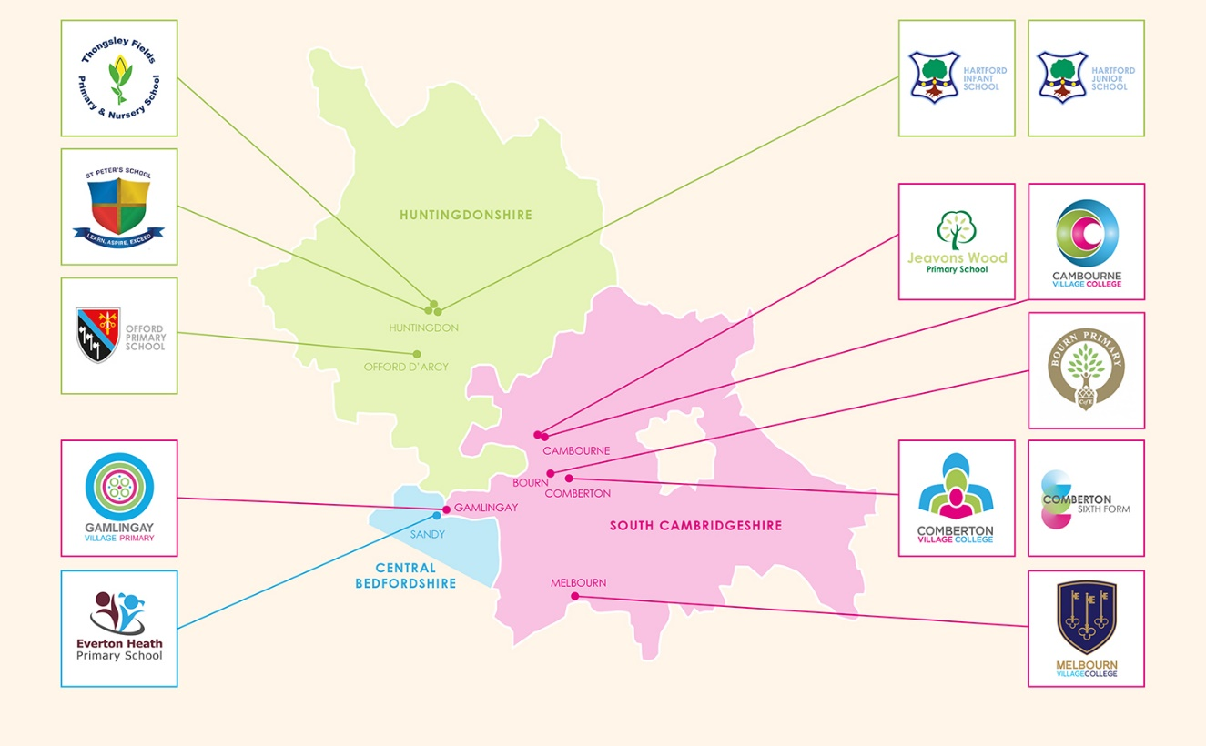
Comberton Village College & Comberton Sixth Form
Comberton Village College is a thriving community of approximately 1800 students, including 500 in the Sixth Form which was added to the school in 2011.
It was established in 1960 as part of Henry Morris’ vision for schools being village colleges at the heart of their community and not just places for children to learn. It has a vibrant Adult Education department as well as an on-site Sports and Arts Centre, including a full-size artificial football pitch and spacious performance hall. Current improvements to the much-extended site include the installation of a £multi-million ground-source heat pump to move away from the use of oil.
Cambourne Village College
Cambourne Village College opened as a Free School in 2013 as the first new village college in Cambridgeshire for 30 years. It serves the community of Cambourne, a group of villages located between Cambridge and St Neots.
It has been repeatedly grown since its inception and now has plans for further expansion to include a sixth form from 2023 and further capacity to match growing demand for families moving into Cambourne West, the fourth of the villages it serves. It, too, offers extensive arts and sports facilities for community use.
It was the first school in the Trust to equip its students with iPads, an initiative now being rolled out across the Trust.
Melbourn Village College
Melbourn Village College is the smallest and oldest of the village colleges in the CAT community. With around 600 students in Years 7-11, it still offers and innovative curriculum with Mandarin taught to all from Year 7 with the option to take the language at GCSE level and, recently, at A Level in conjunction with Comberton Sixth Form.
Melbourn is undergoing considerable investment and improvement with a new artificial pitch that opened in late 2021 and work due to start on upgrading classrooms in summer 2022.
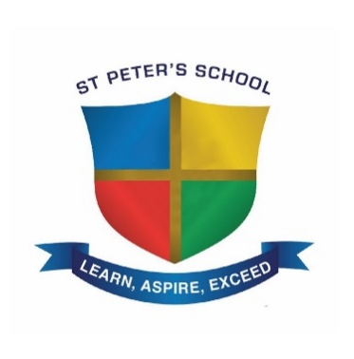
St Peter’s School, Huntingdon
St Peter’s School is located in the heart of Huntingdon and offers a nurturing and supportive environment for around 1200 students from a diverse multi-cultural catchment.
The school joined the Trust in 2016 and has undergone significant change with Ofsted now rating it as a ‘Good’ school. There has also been major investment in its buildings and infrastructure with a complete refurbishment of the Sixth Form and more work scheduled for Summer 2022.
Everton Heath Primary School
Located just over the Bedfordshire border, Everton Heath is the smallest school in the Trust with just over 70 students. However, the installation of two new classrooms in 2021 has given it capacity to grow.
It has joined forced with larger neighbours, Gamlingay Village Primary (less than two miles away) and the second smallest Trust school, Offord Primary, in a new collaborative West Village Partnership. It is a catchment school for Comberton Village College.
Everton Heath Primary School is part of the newly formed West Village Partnership.
Gamlingay Village Primary
Established as a full primary school by the Trust in 2018 from Gamlingay First School, it was relocated to the former middle school site following a major upgrade to the existing buildings.
It is now a thriving school for more than 380 pupils and includes specialist primary provision for students on the autistic spectrum, many of whom go on to Comberton Village College’s similar secondary offering as Comberton is the school’s designated 11-16 provider.
Gamlingay Village Primary School is part of the newly formed West Village Partnership.

Hartford Infant and Preschool
Renamed in early 2022 to reflect the addition of a bespoke preschool, the team are proud of their caring, secure and purposeful environment to nurture youngsters at the start of their educational journey.
The school shares a site with the Junior School in a suburb of Huntingdon and most pupils make the natural transition across the playground before going on to St Peter’s, allowing them the full educational experience within the Trust.
Hartford Junior School
Hartford Junior School has two-form entry at the start of Key Stage 2 with the majority switching from the Infant School next door.
Rated ‘Good’ at their first inspection since joining the Trust in 2017, they are proud of their progress in recent years, based on their ethos of ‘effort, encouragement and excellence’.
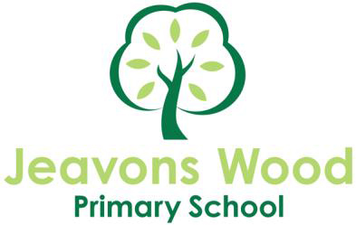
Jeavons Wood Primary School, Cambourne
Jeavons Wood is one of four primary schools located in the growing South Cambridgeshire community of Cambourne and is a feeder school for Cambourne Village College.
It has more than 400 pupils in a modern, airy building constructed 10 years ago and works unswervingly to support all their pupils both socially and academically.
Offord Primary School
The newest full members of the Trust, Offord joined in 2019 and undergone significant changes with a new headteacher and the recent collaborative partnership with Gamlingay and Everton Heath.
They are the first primary school in the Trust to obtain enough iPads for every pupil after securing a generous donation from a local charity which supports education in Offord D’Arcy and Offord Cluny.
Offord Primary School is part of the newly formed West Village Partnership.

Thongsley Fields Primary & Nursery School, Huntingdon
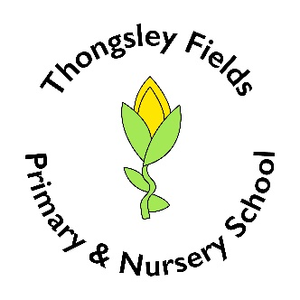
Thongsley Fields Primary & Nursery School was created in 2003 from separate junior and infant schools built to serve families on the Oxmoor estate in Huntingdon. They joined the Trust in 2018 and with a new headteacher are developing grand plans for their curriculum., their grounds and the provision and support for pupils and their families.
Like Hartford Junior School, they are a partner primary for St Peter’s School with whom they share a Governing Body.
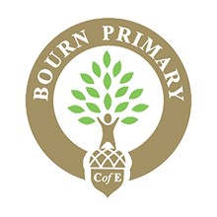
Bourn Primary Academy
Bourn Primary Academy, a single form entry Church of England school, became the Trust’s first associate members in September 2021, cementing an already close relationship with both Comberton and Cambourne Village Colleges, which it lies between.
All the Trust’s services are available to Bourn, which is in the Comberton catchment, and they now work closely with all the other schools and staff across the Trust, sharing experiences and best practice.

Safeguarding Children and Young People
The Cam Academy Trust is committed to safeguarding and promoting the welfare of children and young people and expects all staff and volunteers to share this commitment. Successful candidates will be subject to an enhanced DBS check, barred list check and other relevant pre-employment checks.

The Vacancy
Year 1 Class Teacher at Hartford Infant and Preschool
We welcome applications from experienced staff wishing to broaden their experience.

Required from: September 2022
Pay Scale: Main Scale

Are you an experienced teacher with a great track record looking to work in an infant school setting? Are you skilled in working in KS1 or EYFS?

If the answer is ‘yes’ to either of these questions, this could be the job for you!

We are looking for:
- an ambitious, hard-working, committed teacher with the highest aspirations for all learners and for themselves,
- an excellent practitioner, with a good and/or outstanding track record, who is committed to raising achievement for all,
- a Key Stage One specialist who has experience working across these year groups,
- a practitioner highly skilled in AfL, planning creative lessons which motivate all pupils to learn, and developing an engaging curriculum and environment,
- an excellent communicator with good organisational skills,
- an effective team player who values all stakeholders,
- a caring individual with a happy disposition, who will motivate and inspire pupils whilst promoting the school’s positive ethos.

The role would involve:
- being a class teacher in Year One,
- demonstrating outstanding teaching and learning, classroom management and behaviour management,
- participating in monitoring standards and progress within the class,
- coordinating a subject across the school,
- maintaining an exceptional learning environment,
- working effectively with the Senior Leadership Team and year group colleagues,

We can offer:
- the chance to work in an Outstanding school [Ofsted 2008/9],
- the support of The Cam Academy Trust,
- the opportunity for someone looking to work in an Infant school
- a caring, happy and successful school with a strong sense of shared responsibility at all levels,
- a hardworking and dedicated team with a commitment to raising standards and improving teaching and learning,
- well behaved and motivated pupils,
- a supportive governing body and leadership team to work with.

Visits to the school would be warmly welcomed, phone calls and emails are encouraged to discuss the role.

To apply for this position please submit an application form and covering letter to Rae Lee, Headteacher via the School office.

For further details regarding this vacancy please contact the Headteacher.

Closing date: Midday on Friday 24 June 2022

Interviews: Week commencing 30 June 2022

Information about Hartford Infant and Preschool

Hartford Infant and Preschool is an Academy and we are part of a local MAT (multi-academy trust) called The CAM Academy Trust along with Hartford Junior School, which is situated on a shared site and with which there is close cooperation. The shared site has several playgrounds and a field. Our intake is very broad feeding from both Hartford and the Oxmoor Estate.
Our school has six spacious class bases, a large hall, an office, a library and two additional group rooms. Currently we have 180 children on roll organised into six classes – two Reception classes, two Year 1 classes and two Year 2 classes. Year groups work closely in teams, with a Team Leader who ensures high quality provision is delivered across both classes. Teachers in each year group have PPA at the same time so they can plan together and make joint decisions about the year group. Each class has at least one Teaching Assistant to help meet the demands of the curriculum and needs of individual children.

As a school, we have a strong commitment to continued professional development for all. We believe we are all life-long learners and want to ensure our practice is the best it can be through continual high expectations and a willingness to evaluate and make improvements where necessary. All new members of staff have a formal induction.

In 2008 we were graded as Outstanding by Ofsted. We have gained the Basic Skills Quality Mark four times. These awards are the result of the whole school community working closely together.

On average our children typically enter our Reception Class achieving below the national expectation, but by the time our children leave us their achievements are above, or significantly above the national average, representing good value added.

Hartford Infant and Preschool is well supported by both parents and governors. The parents regularly raise funds to purchase resources for school. Parents are welcome in school and many regularly help.

Part of your role will be to ensure the objectives of the school’s policy for Multicultural and Equality of Opportunity are followed. This policy provides a framework for the school to pursue its equality duties to eliminate unlawful discrimination and harassment, promote equality of opportunity, and promote good relations and positive attitudes between people of diverse backgrounds in all its activities.

Candidates need to be aware that canvassing any member of staff or member of the governing body, directly or indirectly, is prohibited and will disqualify your job application.

If you wish to discuss the post or be given any more information about the school please contact the Headteacher.

Job Description

In accordance with the school’s policies and under the direction of the Headteacher:
The aim of this post is to deliver high quality teaching and learning in the classroom.

In accordance with the school’s policies and under the direction of the Headteacher:
- show, through enthusiastic and imaginative classroom practice, a deep personal understanding and commitment to delivering high quality teaching and learning experiences to pupils in their class;

- continue to develop their own professional skills and judgements in Reception or Key Stage One;

- contribute towards an effective teaching and learning team in which the sharing of ideas, resources and very good practice flourishes. This will include managing Support Staff in the class;

- work in collaboration with other team members in regularly reviewing, refining and implementing the team’s long and medium term planning based upon the school’s schemes of work, to ensure equality of opportunities and experiences for all pupils across the team and to deliver a broad and balanced curriculum;

- attend regular team meetings and PPA where the focus will be continuing to raise standards by:
- ensuring the short term planning is of a high quality,
- recording the evaluation of medium term planning,
- revising planning in the light of previous evaluations,
- ensuring ongoing assessment & moderation of children’s work is undertaken at regular intervals;

- track and regularly review the progress and attainment of pupils in the class, to make future recommendations that will impact upon standards;

- be a valued member of the school and contribute constructively to staff meetings;

- be responsible for leading, managing and developing a curriculum area;

- be responsible for the deployment of teaching assistants assigned to the class;

- liaise regularly with the parents about pupils’ educational progress and to actively support our PTA;

- Safeguarding:

- Be committed to the school’s safeguarding policies and procedures including child protection, internet safety and anti-bullying.

- To conduct your daily activities in line with our code of conduct for all staff.

- Follow the school’ whistle-blowing procedures and policy.

Person Specification
 | Essential | Desirable
Qualifications | - Qualified teacher status | - Evidence of further professional development
Teaching competencies and experience | - Experience as Key Stage One teacher  - Outstanding Key Stage One practitioner  - Understands characteristics of effective and outstanding Reception or Key Stage One teaching and learning  - Understands the requirements of Working with the revises Early Years Foundation Stage  - Understands the requirements of the Key Stage One National Curriculum  - Clear understanding of assessment and its effectiveness  - Has experience of using AfL  - Outstanding understanding of effective techniques and policies for behaviour management  - Effectively plan lessons and use ICT to support this (Smart Notebook, PowerPoint etc.) | - Experience of YR, Y1, Y2 & KS2 teaching  - A good understanding of both the Early Years and National Curriculum
Management competencies and experiences | - Support whole school issues  - Good organisational skills  - Experience of delegating and supporting Teach Assistants  - Ability to analyse, prioritise and meet deadlines  - Experience of subject leadership  - Identify resources required to sustain high quality teaching and learning | - Experience of contributing to School Development Planning  - Experience of leading a core subject in school leading to school improvement
Professional  Qualities and competencies | - A presence which inspires confidence and respect and openness  - A clear vision of primary education  - Ability to explain ideas succinctly  - Promote excellent relationships and communicate with all stakeholders  - Able to work in partnership with other class teachers within the year group  - Ability to review and revise a standpoint if necessary  - Commitment to safeguarding and promoting the welfare of children | - Experience of having led a whole school initiative  - Experience of a culture where everyone feels confident that they can raise issues/ concerns relating to the welfare/ safety of children  - Has liaised with governors on the LGB
Personal Qualities | - Is approachable, caring, and empathetic  - Works well as part of a team  - Shows a high level of enthusiasm, commitment, and dedication  - Is flexible and listens  - Is prepared to seek advice and support  - Confidentiality, commitment, and loyalty  - Commitment to continuing professional development  - Self-motivated and shows initiative  - Committed to active parental involvement  - Resilient under pressure  - The ability to deal sensitively with people and resolve conflict | - Has a desire to support all aspects of children’s development

