Date as postmark

Dear Sir/Madam

Thank you for your interest in the Primary Class teacher post at Normand Croft Community School.

Please find enclosed information about our school with the job description and the selection criteria and an application form.

It’s important that you ensure that your supporting statement in the application form gives examples of how you feel you meet the selection criteria.

The closing date for your application to be returned to school is: 18 May 2018
You are most welcome to visit the school or ring me on the number below for an informal chat about the job.

Good luck with your application,

Yours sincerely
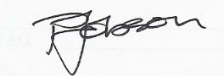

Paul Jobson
Head teacher

